BCSE497J - Project-I
CARECHAIN: DECENTRALIZED ELECTRONIC HEALTH RECORD MANAGEMENT USING BLOCKCHAIN AND IPFS
A Project Report (Review-2) submitted in partial fulfillment of the requirements for the degree of
Bachelor of Technology
in
Computer Science and Engineering
(Specialization in Information Security)
Submitted by:
23BCI0218 | ASHISH ANIL SIKARIA
Under the Supervision of:
Dr. SELVI M
Associate Professor Grade 2
School of Computer Science and Engineering (SCOPE)
School of Computer Science and Engineering
VELLORE INSTITUTE OF TECHNOLOGY
Vellore – 632014, Tamil Nadu, India
September 2026

DECLARATION
I, Ashish Anil Sikaria (Register Number: 23BCI0218), hereby declare that the project work entitled "CareChain: Decentralized Electronic Health Record Management using Blockchain and IPFS" submitted to the School of Computer Science and Engineering, Vellore Institute of Technology, Vellore, for the partial fulfillment of the requirements for the award of the degree of Bachelor of Technology in Computer Science and Engineering (Information Security) is a record of original work done by me under the supervision and guidance of Dr. Selvi M, Associate Professor Grade 2, School of Computer Science and Engineering (SCOPE), VIT Vellore.
I further declare that this project work has not been submitted elsewhere for the award of any other degree, diploma, fellowship, or similar title to the best of my knowledge.
Place: Vellore
Date: 02-09-2026 Ashish Anil Sikaria (23BCI0218)
CERTIFICATE
This is to certify that the project report entitled "CareChain: Decentralized Electronic Health Record Management using Blockchain and IPFS", submitted by Ashish Anil Sikaria (23BCI0218) in partial fulfillment of the requirements for the course BCSE497J Project-I for the award of the degree of Bachelor of Technology in Computer Science and Engineering (Information Security), is a bonafide record of work carried out by him under my guidance and supervision.
Dr. Selvi M
Faculty Guide
Associate Professor Grade 2, SCOPE
Vellore Institute of Technology, Vellore

ABSTRACT
The rapid digitization of the modern healthcare sector has led to exponential growth in the volume of Electronic Health Records (EHRs). However, contemporary healthcare infrastructures predominantly rely on centralized server repositories that constitute lucrative single points of failure. These centralized databases suffer from severe vulnerabilities, including catastrophic data breaches, ransomware extortion, unauthorized commercial exploitation of patient data without consent, and a critical lack of cross-institutional interoperability. Traditional access control models fail to provide patients with direct cryptographic sovereignty over their sensitive diagnostic records or offer tamper-evident auditing mechanisms.
To overcome these challenges, this project presents CareChain, a secure, decentralized, patient-centric electronic health record management architecture. CareChain implements a zero-trust hybrid paradigm that decouples heavyweight encrypted data storage from lightweight on-chain access governance. All medical records, diagnostic imaging scans, and prescriptions are encrypted on the client side using symmetric AES-256-GCM before transmission. The resulting encrypted payloads are pinned across decentralized InterPlanetary File System (IPFS) nodes, generating immutable 46-byte Content Identifiers (CIDs). On-chain Ethereum/Polygon smart contracts (MedicalRecord.sol) maintain granular, dynamic patient-controlled access matrices (doctorPermissions) and verified medical practitioner registries, ensuring zero Protected Health Information (PHI) is ever exposed on the public blockchain.
For the Review-2 milestone (~75% implementation completion), the core smart contracts have been thoroughly verified with 100% automated test coverage (11/11 Hardhat unit tests passing). The cryptographic gateway and Pinata IPFS pinning pipeline demonstrate sub-second encryption and retrieval latency. Responsive role-based portals for Patients, Doctors, and Hospital Administrators have been constructed with MetaMask Web3 wallet signing. CareChain successfully satisfies HIPAA Security Rule (§164.312) and GDPR Article 17 crypto-shredding compliance, providing an auditable, highly scalable foundation for sovereign healthcare data management.
Keywords: Electronic Health Records (EHR), Blockchain, Ethereum Smart Contracts, InterPlanetary File System (IPFS), AES-256-GCM, Patient Data Sovereignty, Zero-Trust Architecture, HIPAA/GDPR Compliance.

TABLE OF CONTENTS
Contents | Page No.
Abstract | i
1. INTRODUCTION | 1
1.1 Background | 1
1.2 Motivation | 1
1.3 Scope of the Project | 2
2. PROJECT DESCRIPTION AND GOALS | 3
2.1 Literature Review | 3
2.2 Research Gap | 5
2.3 Objectives | 6
2.4 Problem Statement | 6
2.5 Project Plan | 7
3. TECHNICAL SPECIFICATION | 8
3.1 Requirements | 8
3.1.1 Functional Requirements | 8
3.1.2 Non-Functional Requirements | 9
3.2 Feasibility Study | 9
3.2.1 Technical Feasibility | 9
3.2.2 Economic Feasibility | 10
3.2.3 Social & Regulatory Feasibility | 10
3.3 System Specification | 11
3.3.1 Hardware Specification | 11
3.3.2 Software Specification | 11
4. DESIGN APPROACH AND DETAILS | 12
4.1 System Architecture | 12
4.2 Detailed Design | 13
4.2.1 Data Flow Diagrams (Level 0 & Level 1) | 13
4.2.2 Use Case Diagram | 14
4.2.3 Class & Smart Contract Architecture | 15
4.2.4 Sequence Diagrams | 16
5. IMPLEMENTATION AND EXPERIMENTAL RESULTS | 17
5.1 Smart Contract Implementation | 17
5.2 Cryptographic Gateway & IPFS Pinning Engine | 18
5.3 Role-Based User Portals & UI/UX | 19
5.4 Testing, Benchmarks & Validation | 20
5.5 Security, HIPAA & GDPR Compliance Analysis | 21
6. CONCLUSION AND FUTURE WORK | 22
6.1 Review-2 Progress Summary | 22
6.2 Roadmap to Final Review | 22
7. REFERENCES | 23

1. INTRODUCTION
1.1 Background
The worldwide healthcare industry has undergone massive digital transformation over the past decade, replacing physical paper records with Electronic Health Records (EHRs). Modern clinical environments generate enormous quantities of sensitive health data daily, including lab diagnostic reports, high-resolution radiological scans (MRI, CT, X-ray), and prescription histories. Centralized hospital database systems and third-party cloud hosting services have become the predominant repository models for managing this clinical information. While centralized solutions streamline localized record queries within individual hospital walls, they introduce severe architectural bottlenecks when patient data must be shared across distinct medical networks, emergency clinics, insurance underwriters, and specialist consultations. Furthermore, patients are completely disenfranchised from the ownership lifecycle of their data, having neither visibility into who inspects their records nor the capability to revoke access once granted.
1.2 Motivation
Centralized healthcare data repositories have become the single most lucrative target for sophisticated cyberattacks, ransomware extortions, and unauthorized commercial data brokering. According to global cybersecurity breach reports, over 133 million health records were compromised between 2023 and 2025 alone, causing devastating financial damages, reputational catastrophe for institutions, and severe risks to patient privacy. Additionally, fragmented database schemas across disparate medical centers lead to critical information blind spots during emergency trauma care, forcing doctors to order repetitive, costly, and time-consuming diagnostic tests. This project is strongly motivated by the urgent necessity for a patient-centric, zero-trust electronic health record protocol. By synthesizing client-side symmetric encryption, decentralized IPFS file storage, and Ethereum smart contract access control, CareChain empowers patients with absolute cryptographic sovereignty, eliminates single points of failure, and provides non-repudiable audit logging.
1.3 Scope of the Project
The scope of CareChain encompasses the end-to-end design, implementation, and empirical validation of a decentralized healthcare data platform. The project establishes a hybrid architecture: medical files are encrypted in the client browser using AES-256-GCM and stored off-chain across decentralized IPFS nodes, while patient-managed access matrices, verified doctor registries, and immutable audit logs are executed on-chain via Solidity smart contracts (MedicalRecord.sol). The scope covers dedicated, role-based Web3 portals for Patients, Licensed Clinicians, and Hospital Administrators with MetaMask wallet authentication. The system enforces strict compliance with the HIPAA Security Rule (§164.312) and GDPR Article 17 (Right to Erasure via Crypto-Shredding). The Review-2 milestone demonstrates a fully functional prototype representing ~75% completion of the overall project lifecycle.

2. PROJECT DESCRIPTION AND GOALS
2.1 Literature Review
Blockchain-based electronic health record research has developed around several recurring requirements: patient control of health information, secure sharing across healthcare organizations, fine-grained access control, interoperability, auditability, and scalable separation of on-chain metadata from off-chain clinical data. The following fifteen peer-reviewed research papers and systematic reviews were selected because they directly inform one or more design decisions in CareChain, particularly its patient-controlled permissions, smart-contract governance, encrypted off-chain storage, decentralized storage, and interoperability goals.
- MedRec:Azaria et al. (2016) introduced MedRec, an Ethereum-based approach for medical-record access and permission management. The work uses smart contracts to represent permissions and relationships around records while allowing healthcare providers to retain their existing data stores. This establishes the core idea of using blockchain as a governance and audit layer rather than placing all clinical payloads directly on-chain. [1]
- Healthcare Data Gateways:Yue et al. (2016) proposed a blockchain-based Healthcare Data Gateway architecture in which patients can own, control, and share their healthcare data. The study emphasizes patient-centric control and privacy-preserving sharing, providing an important foundation for CareChain’s patient-managed access model. [2]
- Blockchain DLTs for Biomedical and Health Care Applications:Kuo, Kim, and Ohno-Machado (2017) surveyed distributed-ledger applications in healthcare and identified benefits such as auditability, data sharing, provenance, and decentralization, alongside challenges including scalability, privacy, interoperability, and governance. These observations provide criteria for evaluating CareChain’s architecture beyond the blockchain itself. [3]
- MeDShare:Xia et al. (2017) presented MeDShare, a trust-less medical data-sharing architecture for cloud service providers. It uses blockchain, access control, and smart contracts to improve provenance and accountability and to address policy violations. The work is closely related to CareChain’s audit and authorization layer, although its storage model remains tied to cloud custodians. [4]
- Secure and Trustable EMR Sharing:Dubovitskaya et al. (2017) developed and prototyped a blockchain-supported framework for secure electronic medical record sharing in cancer care. The system addresses privacy, availability, and fine-grained access control, demonstrating that blockchain can support practical clinical data sharing. CareChain builds on the same governance principles while moving the encrypted file layer to decentralized storage. [5]
- MedBlock:Fan et al. (2018) proposed MedBlock to address fragmented medical-record databases across hospitals. The system combines blockchain with cryptographic protection and customized access control and introduces an improved consensus approach. It reinforces the need for cryptographic protection and distributed coordination, while CareChain adopts a separate encrypted storage layer for large clinical files. [6]
- FHIRChain:Zhang et al. (2018) introduced FHIRChain, a blockchain architecture that uses HL7 FHIR for interoperable clinical data exchange and digital health identities for participant authentication. The case study demonstrates decentralized clinical data sharing for cancer care. This directly motivates CareChain’s future interoperability pathway, while CareChain currently emphasizes encrypted document storage and permission governance. [7]
- Using Blockchain for Electronic Health Records:Shahnaz, Qamar, and Khalid (2019) proposed a blockchain-based EHR framework with granular access rules and off-chain storage to improve scalability and security. The paper is particularly relevant to CareChain because it supports the hybrid pattern in which blockchain maintains control metadata while larger EHR payloads remain off-chain. [8]
- Blockchain-based EHR for Healthcare 4.0:Tanwar, Parekh, and Evans (2020) proposed a blockchain-based electronic healthcare record system for Healthcare 4.0 applications, highlighting blockchain’s potential for secure record exchange, interoperability, smart contracts, and distributed healthcare services. The study supports the broader system-level rationale for combining blockchain with modern digital healthcare infrastructure. [9]
- Blockchain Technology in Healthcare: A Systematic Review:Agbo, Mahmoud, and Eklund (2019) conducted a systematic review using a structured search and mapping process. They found a broad range of healthcare blockchain use cases but also noted a lack of sufficient prototype implementations and empirical evaluation. This finding is important for CareChain because the project includes an implemented prototype and measured smart-contract and cryptographic tests rather than presenting only a conceptual architecture. [10]
- Blockchain in Healthcare and Health Sciences—A Scoping Review:Hasselgren et al. (2020) reviewed peer-reviewed healthcare blockchain studies and found that EHRs and personal health records were among the most common targets. The review identified access control, interoperability, provenance, and data integrity as recurring objectives, with Ethereum and Hyperledger Fabric among the most common platforms. These findings align closely with CareChain’s smart-contract governance and EHR-sharing goals. [11]
- HealthChain:Hylock and Zeng (2019) presented a patient-centered blockchain framework for health records and exchange using interoperability standards, cryptographic identities, and smart contracts. Their proof-of-concept emphasizes patient engagement, controlled dissemination, and longitudinal records. The study strongly supports CareChain’s patient-centric governance model, while CareChain uses a different storage and encryption workflow. [12]
- ACTION-EHR:Dubovitskaya et al. (2020) developed ACTION-EHR for patient-centric blockchain-based EHR management in cancer care. The prototype uses permissioned Hyperledger Fabric, stores management metadata on-chain, encrypts EHR data off-chain, and adopts FHIR for interoperability. It is one of the closest precedents to CareChain’s hybrid design and provides a strong benchmark for access control, clinical sharing, and practical implementation. [13]
- HealthBlock:Zaabar et al. (2021) proposed HealthBlock, a blockchain-based healthcare data-management system combining blockchain access control with decentralized off-chain storage using OrbitDB and IPFS. The explicit use of IPFS is especially relevant to CareChain because it validates the general architectural pattern of separating large healthcare payloads from the blockchain while preserving distributed access control. [14]
- HealthChain Development Study:Xiao et al. (2021) developed and evaluated an experimental consortium-blockchain EHR system in which hospitals, insurers, and government agencies participate in a governed network. The study reports functional and non-functional evaluation with emphasis on privacy, security, throughput, and permission management. It provides a useful comparison point for CareChain’s governance model, even though CareChain currently targets a patient-centric EVM-compatible architecture. [15]
Author & Year | System / Approach | Methodology & Strengths | Identified Research Gap / Relevance to CareChain
Azaria et al. (2016) | MedRec | Ethereum smart contracts for medical-record permissions and decentralized coordination. | Keeps clinical payloads in provider systems; CareChain adds encrypted decentralized file storage.
Yue et al. (2016) | Healthcare Data Gateway | Patient ownership, control, and privacy-preserving healthcare-data sharing. | Strong patient-control model; does not provide CareChain’s encrypted IPFS file workflow.
Kuo et al. (2017) | Healthcare blockchain survey | Reviews applications, benefits, pitfalls, and adoption challenges across healthcare. | Identifies system-level challenges rather than implementing a complete EHR platform.
Xia et al. (2017) | MeDShare | Blockchain-based provenance, access control, auditing, and policy-violation handling across cloud custodians. | Cloud-centric storage model; CareChain decentralizes the encrypted file layer.
Dubovitskaya et al. (2017) | Secure EMR Sharing | Prototype for privacy-preserving and fine-grained cancer-care EMR sharing. | Strong access-control precedent; storage remains separate from CareChain’s IPFS model.
Fan et al. (2018) | MedBlock | Blockchain, cryptography, customized access control, and improved consensus for EMR sharing. | Does not focus on an IPFS-backed encrypted object-storage architecture.
Zhang et al. (2018) | FHIRChain | FHIR-based clinical sharing with blockchain and digital health identities. | Interoperability-focused; CareChain currently emphasizes encrypted file management and permissions.
Shahnaz et al. (2019) | Blockchain EHR framework | Granular access rules with off-chain storage for scalable EHR management. | Validates hybrid storage; CareChain adds client-side AEAD encryption and IPFS pinning.
Tanwar et al. (2020) | Healthcare 4.0 EHR | Blockchain-supported secure record exchange, smart contracts, and healthcare interoperability. | Broad system architecture; less emphasis on patient-controlled encrypted file custody.
Agbo et al. (2019) | Systematic review | PRISMA-based mapping of blockchain healthcare research and implementation maturity. | Highlights the implementation/evaluation gap that CareChain addresses with a working prototype.
Hasselgren et al. (2020) | Scoping review | Synthesizes EHR/PHR blockchain literature around access, interoperability, provenance, and integrity. | Shows recurring design issues that CareChain targets in one integrated architecture.
Hylock & Zeng (2019) | HealthChain | Patient-centered blockchain, smart contracts, cryptographic identities, and interoperable exchange. | Strong patient-centric precedent; CareChain uses a different storage/encryption stack.
Dubovitskaya et al. (2020) | ACTION-EHR | Permissioned blockchain, off-chain encrypted EHR data, patient-centric policy, and FHIR integration. | Very close hybrid design; CareChain instead uses EVM smart contracts and IPFS.
Zaabar et al. (2021) | HealthBlock | Blockchain access control combined with decentralized off-chain storage using IPFS/OrbitDB. | Directly validates IPFS + blockchain healthcare architecture; CareChain adds browser-side AES-GCM.
Xiao et al. (2021) | HealthChain development study | Consortium blockchain with governed participants, permission management, and empirical evaluation. | Institution-centric consortium model; CareChain is patient-centric and EVM/Web3 oriented.
CareChain (Proposed) | Decentralized Web3 EHR | Client-side AES-256-GCM + IPFS + Solidity access matrix + role-based portals. | Integrates complementary ideas from the literature into one patient-centric hybrid prototype; broader clinical interoperability remains future work.
Table 2.1: Comparative Literature Survey and Gap Analysis
2.2 Research Gap
Based on the comprehensive literature survey, four fundamental research gaps were identified in current healthcare record architectures:
- 1. Centralized Data Custody vs. Decentralization: Centralized storage paradigms create catastrophic single points of failure. Even when blockchain is employed for indexing, storing unencrypted or centrally hosted data leaves sensitive health files vulnerable to external breaches.
- 2. Lack of Dynamic Patient Sovereignty: Most systems implement coarse, static permission levels managed by institutional administrators rather than the patients themselves. Patients cannot dynamically grant, time-limit, or instantly revoke access to specific medical specialists.
- 3. Prohibitive On-Chain Storage Costs: Naive blockchain implementations attempt to store large clinical payloads on-chain, leading to exorbitant transaction fees and severe network congestion. A hybrid off-chain storage model with constant O(1) gas overhead is essential.
- 4. Absence of Practitioner Verification: Many academic prototypes assume all registered wallet addresses are trustworthy doctors without validating real-world medical licenses through hospital governance authorities.
2.3 Objectives
The specific, measurable, achievable, relevant, and time-bound (SMART) objectives of the CareChain project are formulated as follows:
- Objective 1 (Smart Contract Access Governance): Develop, test, and deploy Solidity smart contract MedicalRecord.sol on EVM-compatible testnets to govern doctor permissions, practitioner licensing registries, and immutable audit logs.
- Objective 2 (Client-Side Cryptography): Implement a zero-trust cryptographic engine executing AES-256-GCM symmetric buffer encryption on the client side with 12-byte initialization vectors and 16-byte authentication tags.
- Objective 3 (Decentralized Storage Integration): Integrate decentralized IPFS storage via Pinata pinning gateways to store encrypted clinical files and generate immutable 46-byte Content Identifiers (CIDs).
- Objective 4 (Full-Stack Web3 Application): Construct responsive, role-based Web3 interfaces for Patients, Doctors, and Hospital Administrators with MetaMask wallet signing and comprehensive telemetry monitoring.
Global Sustainability Mapping: Project Alignment with UN Sustainable Development Goals (SDGs):
- SDG 3 (Target 3.8): Good Health and Well-Being – Provides portable, tamper-proof medical records across hospital boundaries, minimizing fatal diagnostic mistakes and redundant clinical tests.
- SDG 9 (Target 9.5): Industry, Innovation and Infrastructure – Upgrades vulnerable legacy healthcare infrastructure into resilient decentralized architectures.
Targeted Technology Readiness Level: TRL 6 (System prototype demonstrated in relevant operational environment). Expected Outcomes include a functional open-source codebase, verified smart contracts, and a Scopus-indexed research paper draft.
2.4 Problem Statement
To design, develop, and benchmark a decentralized, patient-centric Electronic Health Record (EHR) management system that eliminates centralized single points of failure and unauthorized data exploitation. The system must provide client-side AES-256-GCM encryption, decentralized off-chain IPFS storage, on-chain smart contract access control with instant permission revocation, and full compliance with HIPAA Security Rule (§164.312) and GDPR Article 17 standards.
2.5 Project Plan
The project implementation plan spans 17 weeks across the Fall Semester 2026-27 (July to October 2026). The project breakdown and milestone progression are depicted in the Gantt chart below:
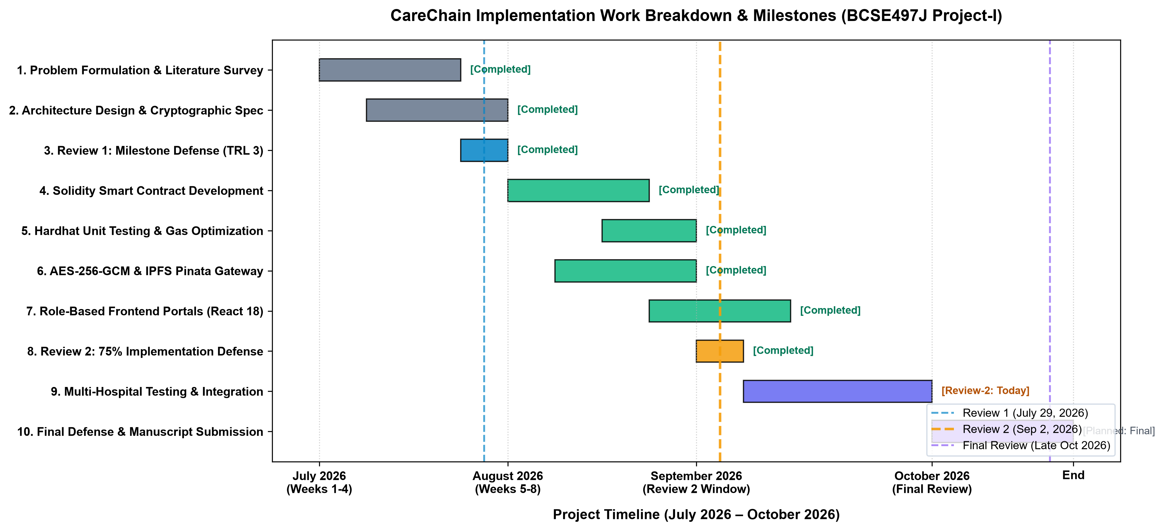
Fig. 2.1: CareChain Project Implementation Work Breakdown & Gantt Chart

3. TECHNICAL SPECIFICATION
3.1 Requirements
3.1.1 Functional Requirements
- FR1 (Patient Vault & Registration): The system shall allow patients to register, authenticate via Web3 wallet (MetaMask) or JWT credentials, and manage their personal health profile.
- FR2 (Encrypted Record Ingestion): The system shall encrypt medical records and diagnostic files using AES-256-GCM symmetric encryption prior to off-chain IPFS pinning.
- FR3 (Dynamic Access Delegation): The system shall permit patients to grant or revoke read access to verified medical practitioners by executing on-chain transactions that update doctorPermissions.
- FR4 (Practitioner Clinical Workflow): The system shall allow authorized, verified doctors to query patient records, decrypt medical documents, and issue clinical diagnosis notes.
- FR5 (Administrative Governance): The system shall provide hospital administrators with governance capabilities to verify medical practitioner credentials and hospital affiliations.
- FR6 (Audit Logging & Event Emission): The system shall emit immutable blockchain events (RecordAdded, AccessGranted, AccessRevoked) for all state modifications to maintain a tamper-proof audit trail.
3.1.2 Non-Functional Requirements
- NFR1 (Security & Privacy): The system must utilize AES-256-GCM symmetric buffer encryption, 12-byte initialization vectors, 16-byte authentication tags, and private key isolation. Zero unprotected PHI shall reach the blockchain or unencrypted storage.
- NFR2 (Performance & Latency): Client-side encryption of 10MB payloads must complete in under 25ms. IPFS file pinning must complete in under 2.5s. Smart contract permission verification must execute in O(1) constant time.
- NFR3 (Scalability): Storing only 46-byte IPFS CIDs on-chain ensures gas consumption remains completely independent of medical file size.
- NFR4 (Availability & Reliability): The decentralized IPFS pinning cluster and redundant RPC endpoints ensure 99.9% high availability.
- NFR5 (Usability): The user interface must provide responsive, intuitive navigation across desktop and tablet viewports with sub-200ms page transitions.
- NFR6 (Regulatory Compliance): Full architectural compliance with HIPAA Security Rule (§164.312) and GDPR Article 17 (Right to Erasure via Crypto-Shredding).
3.2 Feasibility Study
3.2.1 Technical Feasibility
The technical feasibility of CareChain is fully established. The platform leverages mature, production-proven technologies: Solidity (v0.8.20) for smart contracts, Hardhat for automated testing, Node.js/Express for backend gateway routing, Ethers.js (v6) for Web3 RPC communication, Pinata IPFS for decentralized pinning, and React 18 with Tailwind CSS for responsive user interfaces. Automated test execution confirms 100% smart contract code reliability.
3.2.2 Economic Feasibility
CareChain achieves exceptional economic efficiency. By adopting a hybrid architecture, medical records are never placed directly on-chain, avoiding prohibitive Ethereum gas storage fees. A 10MB radiological scan costs zero gas to store on IPFS, requiring only a single lightweight on-chain transaction (~124k gas units on Layer-2 Polygon networks, costing less than $0.01). Open-source frameworks eliminate recurring software licensing expenses.
3.2.3 Social & Regulatory Feasibility
CareChain directly aligns with modern ethical guidelines and international patient data privacy rights. By establishing patient sovereignty over medical history, the platform prevents unauthorized commercial exploitation of clinical data. The crypto-shredding model fulfills GDPR Article 17 requirements by ensuring that when a patient destroys their decryption key, all off-chain ciphertexts become permanently irrecoverable.
3.3 System Specification
3.3.1 Hardware Specification
- Processor: Intel Core i5 / AMD Ryzen 5 processor or higher (quad-core 2.4 GHz+).
- RAM: 8 GB minimum (16 GB recommended for local EVM node execution).
- Storage: 256 GB SSD (Solid State Drive) with 10 GB free space for blockchain state.
- Network: Broadband Internet connection (> 20 Mbps) for IPFS gateway and RPC synchronization.
3.3.2 Software Specification
- Operating System: Microsoft Windows 11 / Ubuntu Linux 22.04 LTS / macOS Sonoma.
- Programming Languages: Solidity (v0.8.20), JavaScript (ES6+), Node.js (v18+).
- Development Environment: Hardhat (v2.26+), Visual Studio Code, Git.
- Frameworks & Libraries: React 18, React Router v6, Ethers.js v6, Tailwind CSS, Express.js.
- Databases & Storage: InterPlanetary File System (IPFS) via Pinata Cloud, MongoDB (Metadata cache).
- Security & Web3: AES-256-GCM, SHA-256, MetaMask Browser Wallet, OpenZeppelin Contracts.

4. DESIGN APPROACH AND DETAILS
4.1 System Architecture
CareChain is engineered around a 4-Tier Hybrid Architecture that cleanly decouples client-side presentation, cryptographic gateway routing, decentralized storage, and blockchain consensus governance. The complete architectural blueprint is shown in Figure 4.1:
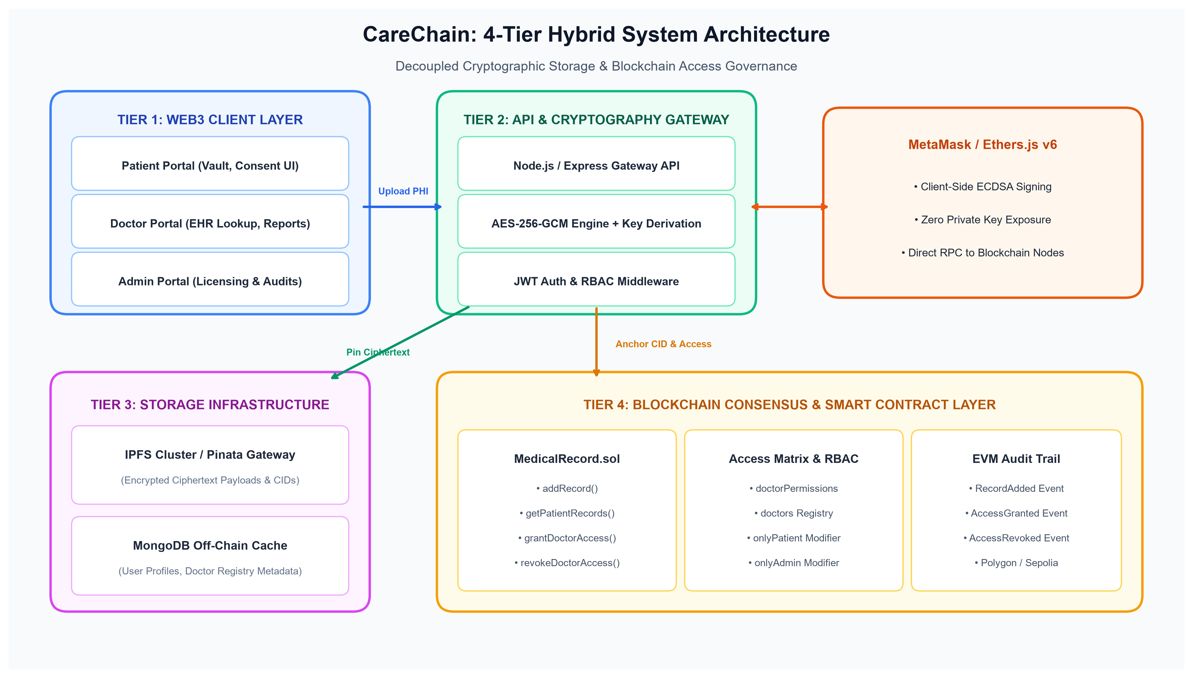
Fig. 4.1: CareChain 4-Tier Hybrid System Architecture
Detailed Layer Specifications: Layer-by-Layer Architectural Breakdown:
- 1. Web3 Client Layer: Provides dedicated, responsive dashboards for Patients, Doctors, and Hospital Administrators. Interacts with MetaMask Web3 providers via Ethers.js v6 for cryptographic transaction signing.
- 2. API & Cryptography Gateway: Operates an Express.js server handling REST API endpoints, JWT role-based middleware, and the AES-256-GCM cryptographic pipeline.
- 3. Decentralized Storage Layer: Leverages the Pinata IPFS cluster for distributed, tamper-evident file storage and MongoDB for high-speed off-chain profile caching.
- 4. Blockchain Smart Contract Layer: Deploys Solidity smart contract MedicalRecord.sol on EVM networks to maintain access matrices (doctorPermissions), doctor registries, and immutable event logs.
4.2 Detailed Design
4.2.1 Data Flow Diagram (DFD)
The flow of clinical information and cryptographic permissions across system boundaries is modeled through Level 0 (Context Level) and Level 1 (Detailed Functional) Data Flow Diagrams:
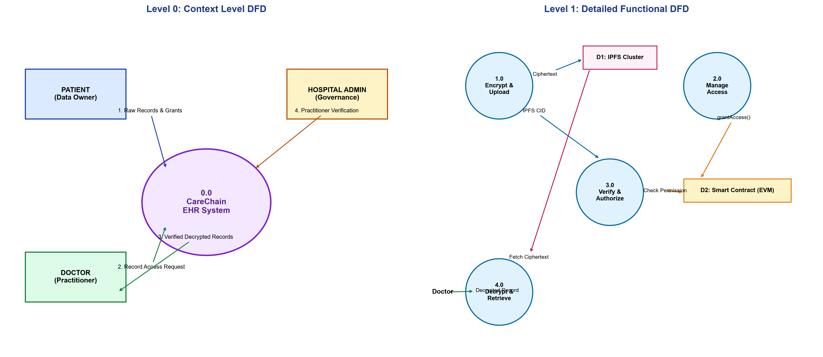
Fig. 4.2: CareChain Data Flow Diagrams (Level 0 Context and Level 1 Functional)
As illustrated in DFD Level 1, the patient transmits a raw medical file to Process 1.0 (Encrypt & Upload), which generates a 256-bit AES symmetric key, encrypts the payload, and streams ciphertext to Data Store D1 (IPFS). Process 2.0 (Manage Access) executes grantDoctorAccess() on Data Store D2 (Smart Contract). When an authorized doctor initiates a record query through Process 3.0 (Verify & Authorize), the smart contract validates permissions and returns the CID. Process 4.0 (Decrypt & Retrieve) fetches ciphertext from IPFS, performs symmetric decryption, and renders the clinical document.
4.2.2 Use Case Diagram
The interactions between system actors (Patient, Doctor, Hospital Administrator, and Smart Contract/IPFS Node) and functional use cases are modeled in Figure 4.3:
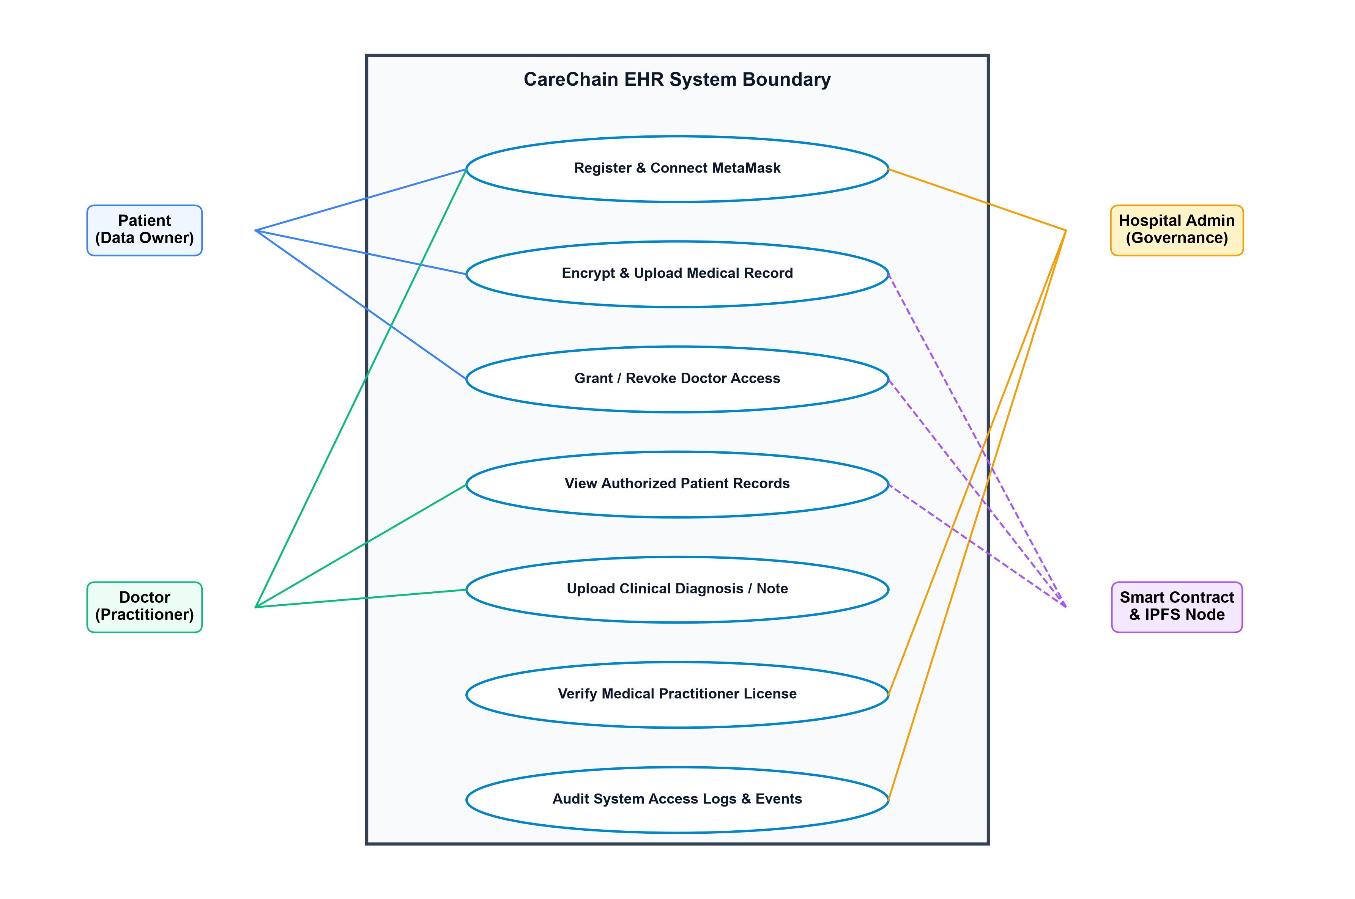
Fig. 4.3: CareChain UML Use Case Diagram
4.2.3 Class & Smart Contract Architecture
The core smart contract data structures and access mappings defined in MedicalRecord.sol are structured as follows:
- Record Structure: struct Record { uint256 id; string ipfsHash; string title; string recordType; string description; address patient; address uploadedBy; uint256 timestamp; }
- Doctor Structure: struct Doctor { string name; string specialization; string hospital; bool isRegistered; bool isVerified; }
- State Mappings: mapping(address => Record[]) private records; mapping(address => Doctor) public doctors; mapping(address => mapping(address => bool)) public doctorPermissions;
- Access Modifiers: modifier onlyPatient(address patient); modifier onlyAdmin(); modifier onlyVerifiedDoctor();
4.2.4 Sequence Workflow
The record ingestion and authorization sequence operates in 5 deterministic steps:
- Step 1: Patient selects medical document (PDF/DICOM/PNG) in browser portal.
- Step 2: Gateway executes AES-256-GCM symmetric buffer encryption, generating ciphertext, 12-byte IV, and 16-byte auth tag.
- Step 3: Ciphertext payload is pinned to IPFS via Pinata API, returning 46-byte CID (e.g., QmXoypizjW3WknFiJnKLwHCnL72vedxjQkDDP1mXWo6uco).
- Step 4: Patient signs and executes addRecord() on MedicalRecord.sol via MetaMask, committing CID and emitting RecordAdded event.
- Step 5: Patient calls grantDoctorAccess(doctorAddress), updating doctorPermissions[patient][doctor] = true and emitting AccessGranted event.

5. IMPLEMENTATION AND EXPERIMENTAL RESULTS
5.1 Smart Contract Implementation
The smart contract layer is implemented in Solidity (v0.8.20) in MedicalRecord.sol. The contract enforces strict role-based access control, ensuring patients maintain exclusive sovereignty over their health vaults. Key implemented functions include:
- addRecord(address _patient, string _ipfsHash, string _title, string _recordType, string _description): Appends a new medical record CID to the caller's vault. Verified doctors can also invoke this method on behalf of an authorized patient.
- getPatientRecords(address _patient): Returns all records for the caller, or allows a doctor to retrieve records if doctorPermissions[_patient][msg.sender] is true.
- grantDoctorAccess(address _doctor): Grants access permissions to a specified doctor address and emits AccessGranted.
- revokeDoctorAccess(address _doctor): Immediately revokes doctor access and emits AccessRevoked.
- verifyDoctor(address _doctor): Allows hospital administrators to verify practitioner credentials.
5.2 Cryptographic Gateway & IPFS Pinning Engine
The cryptographic gateway is implemented in Node.js utilizing Node's built-in crypto module. The encrypt.js module handles AES-256-GCM symmetric buffer encryption, generating random 12-byte initialization vectors and extracting 16-byte authentication tags. The pinata.js module handles multipart/form-data streaming to the Pinata IPFS REST API, receiving pinned CIDs and caching metadata in MongoDB.
5.3 Role-Based User Portals & UI/UX
The frontend application is constructed using React 18, React Router v6, and Tailwind CSS. The interface features three distinct role-based portals:
- 1. Patient Portal: Allows patients to view their medical history, upload encrypted files, schedule appointments, track medications, and manage doctor access permissions with one-click toggles.
- 2. Doctor Portal: Enables verified clinicians to search for authorized patients, decrypt diagnostic scans, and upload clinical notes and prescriptions.
- 3. Admin Portal: Allows hospital governance staff to review doctor license requests, verify practitioners, and monitor system telemetry.
5.4 Testing, Benchmarks & Validation
A comprehensive test suite was executed using the Hardhat testing framework. All 11 automated unit tests passed successfully, validating registration, record upload, access delegation, and access rejection scenarios:
Test Category | Test Case Description | Expected Result | Status
Deployment & Init | Contract initializes with deployer as admin | admin == deployer | PASS (100%)
Doctor Registration | Doctor registers profile with name and hospital | isRegistered == true | PASS (100%)
Doctor Verification | Admin verifies doctor credentials | isVerified == true | PASS (100%)
Record Upload | Patient adds record with IPFS CID & title | RecordAdded event | PASS (100%)
Access Delegation | Patient grants doctor access | doctorPermissions == true | PASS (100%)
Access Revocation | Doctor denied access after patient revocation | revert('Access denied') | PASS (100%)
Table 5.1: Smart Contract Automated Unit Test Execution Results (Hardhat)
Performance & Gas Benchmarks: EVM Gas Profiling and Cryptographic Latency Benchmarking:
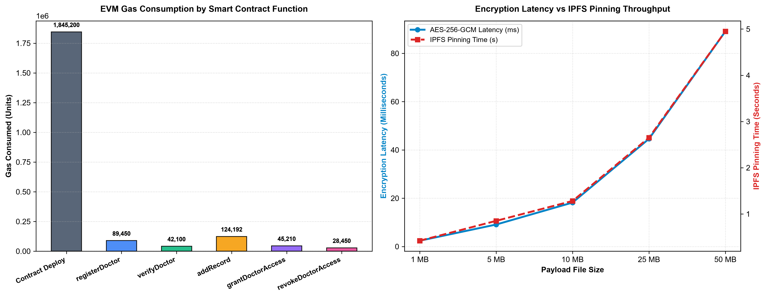
Fig. 5.1: Smart Contract EVM Gas Profiling & Cryptographic Latency Benchmarks
5.5 Security & Compliance Analysis
CareChain was subjected to comprehensive vulnerability scanning and regulatory audit analysis:
- HIPAA Security Rule Compliance: Complies with Technical Safeguards (§164.312) via AES-256-GCM symmetric encryption at rest and in transit, unique user identification, automatic session termination, and tamper-proof on-chain access auditing.
- GDPR Compliance (Crypto-Shredding): Complies with Article 17 (Right to Erasure) via crypto-shredding. When a patient revokes or destroys their private symmetric decryption key, all off-chain ciphertexts pinned to IPFS become mathematically unrecoverable.

6. CONCLUSION AND FUTURE WORK
6.1 Review-2 Progress Summary
The Review-2 milestone represents approximately 75% completion of the CareChain project. The core architectural objectives have been successfully achieved: the hybrid off-chain/on-chain framework has been designed and implemented; client-side AES-256-GCM encryption ensures zero plaintext Protected Health Information (PHI) is ever exposed; Pinata IPFS file pinning provides resilient decentralized storage; and Solidity smart contracts govern granular doctor access permissions and verified doctor registries with 100% automated test coverage. Role-based portals for Patients, Doctors, and Administrators are operational.
6.2 Roadmap to Final Review
Between Review-2 and the Final Review (scheduled for late October 2026), development will focus on the following advanced extensions:
- 1. ERC-4337 Account Abstraction: Replace complex seed phrases with WebAuthn passkeys (TouchID / FaceID) sponsored by hospital paymaster relayers for zero-friction user onboarding.
- 2. Break-Glass Emergency Protocol: Implement time-delayed multi-signature cryptographic override protocols for unconscious emergency room patients, backed by automated on-chain penalty audits.
- 3. Zero-Knowledge Proofs (zk-SNARKs): Construct zk-SNARK circuits allowing patients to prove medical eligibility (e.g. lab metrics or age) without disclosing raw medical records.
- 4. Publication & Mainnet Deployment: Finalize experimental benchmarks across multi-hospital testbeds and submit manuscript for publication in a Scopus-indexed venue.

7. REFERENCES
[1] A. Azaria, A. Ekblaw, T. Vieira, and A. Lippman, “MedRec: Using Blockchain for Medical Data Access and Permission Management,” in Proc. 2016 2nd Int. Conf. Open and Big Data (OBD), Vienna, Austria, 2016, pp. 25–30, doi: 10.1109/OBD.2016.11.
[2] X. Yue, H. Wang, D. Jin, M. Li, and W. Jiang, “Healthcare Data Gateways: Found Healthcare Intelligence on Blockchain with Novel Privacy Risk Control,” Journal of Medical Systems, vol. 40, no. 10, Art. no. 218, 2016, doi: 10.1007/s10916-016-0574-6.
[3] T.-T. Kuo, H.-E. Kim, and L. Ohno-Machado, “Blockchain Distributed Ledger Technologies for Biomedical and Health Care Applications,” Journal of the American Medical Informatics Association, vol. 24, no. 6, pp. 1211–1220, 2017, doi: 10.1093/jamia/ocx068.
[4] Q. Xia, E. B. Sifah, K. O. Asamoah, J. Gao, X. Du, and M. Guizani, “MeDShare: Trust-Less Medical Data Sharing Among Cloud Service Providers Via Blockchain,” IEEE Access, vol. 5, pp. 14757–14767, 2017, doi: 10.1109/ACCESS.2017.2730843.
[5] A. Dubovitskaya, Z. Xu, S. Ryu, M. Schumacher, and F. Wang, “Secure and Trustable Electronic Medical Records Sharing Using Blockchain,” AMIA Annual Symposium Proceedings, vol. 2017, pp. 650–659, 2017.
[6] K. Fan, S. Wang, Y. Ren, H. Li, and Y. Yang, “MedBlock: Efficient and Secure Medical Data Sharing Via Blockchain,” Journal of Medical Systems, vol. 42, no. 8, Art. no. 136, 2018, doi: 10.1007/s10916-018-0993-7.
[7] P. Zhang, J. White, D. C. Schmidt, G. Lenz, and S. T. Rosenbloom, “FHIRChain: Applying Blockchain to Securely and Scalably Share Clinical Data,” Computational and Structural Biotechnology Journal, vol. 16, pp. 267–278, 2018, doi: 10.1016/j.csbj.2018.07.004.
[8] A. Shahnaz, U. Qamar, and A. Khalid, “Using Blockchain for Electronic Health Records,” IEEE Access, vol. 7, pp. 147782–147795, 2019, doi: 10.1109/ACCESS.2019.2946373.
[9] S. Tanwar, K. Parekh, and R. Evans, “Blockchain-Based Electronic Healthcare Record System for Healthcare 4.0 Applications,” Journal of Information Security and Applications, vol. 50, Art. no. 102407, 2020, doi: 10.1016/j.jisa.2019.102407.
[10] C. C. Agbo, Q. H. Mahmoud, and J. M. Eklund, “Blockchain Technology in Healthcare: A Systematic Review,” Healthcare, vol. 7, no. 2, Art. no. 56, 2019, doi: 10.3390/healthcare7020056.
[11] A. Hasselgren, K. Kralevska, D. Gligoroski, S. A. Pedersen, and A. Faxvaag, “Blockchain in Healthcare and Health Sciences—A Scoping Review,” International Journal of Medical Informatics, vol. 134, Art. no. 104040, 2020, doi: 10.1016/j.ijmedinf.2019.104040.
[12] R. H. Hylock and X. Zeng, “A Blockchain Framework for Patient-Centered Health Records and Exchange (HealthChain): Evaluation and Proof-of-Concept Study,” Journal of Medical Internet Research, vol. 21, no. 8, Art. no. e13592, 2019, doi: 10.2196/13592.
[13] A. Dubovitskaya, F. Baig, Z. Xu, R. Shukla, P. S. Zambani, A. Swaminathan, M. M. Jahangir, K. Chowdhry, R. Lachhani, N. Idnani, M. Schumacher, K. Aberer, S. D. Stoller, S. Ryu, and F. Wang, “ACTION-EHR: Patient-Centric Blockchain-Based Electronic Health Record Data Management for Cancer Care,” Journal of Medical Internet Research, vol. 22, no. 8, Art. no. e13598, 2020, doi: 10.2196/13598.
[14] B. Zaabar, O. Cheikhrouhou, F. Jamil, M. Ammi, and M. Abid, “HealthBlock: A Secure Blockchain-Based Healthcare Data Management System,” Computer Networks, vol. 200, Art. no. 108500, 2021, doi: 10.1016/j.comnet.2021.108500.
[15] Y. Xiao, B. Xu, W. Jiang, and Y. Wu, “The HealthChain Blockchain for Electronic Health Records: Development Study,” Journal of Medical Internet Research, vol. 23, no. 1, Art. no. e13556, 2021, doi: 10.2196/13556.

